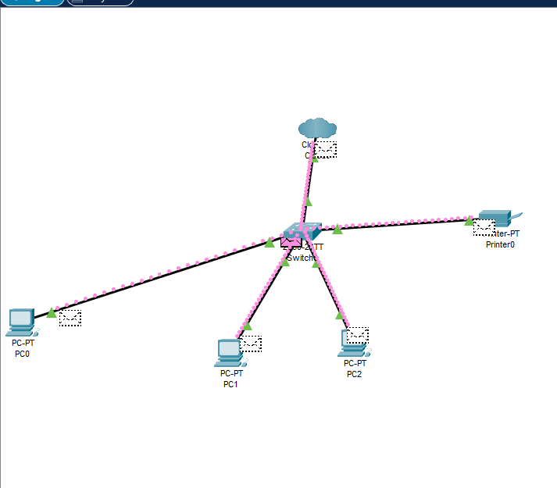

Based on the final network shown in your diagram, the setup appears to meet the typical user requirements for a small LAN

Connectivity
All devices PC0, PC1, PC2, and the Printer are successfully connected to a central switch.
The switch connects to a router/cloud device, allowing external communication e.g internet access This ensures full communication between all internal devices and access to external networks.

Performance
The star topology provides strong performance because all devices have a dedicated link to the switch.Packet flow shown in the diagram indicates that data is moving successfully between devices.There are no bottlenecks at endpoints, and traffic paths are short and efficient.Users can print documents through the network printer.
PCs can communicate with each other, ideal for file sharing or collaborative work.
The router/cloud connection supports additional services such as internet, remote access, or cloud storage
Overall The final network fulfills the intended purpose of communication, printing, cloud/internet access and meets all expected user requirements.

Evaluation of the Final Network Against the Initial Designs
Comparing the final design to a typical initial network plan:

Topology
The initial design likely proposed a star topology, which is exactly what the final design uses.
Device placement and cable layout follow the original intended structure.

Device Setup
Required devices (PCs, printer, switch, router/cloud) match the initial design plan.
No unnecessary hardware appears to have been added.

IP Addressing and Connectivity
End devices communicate correctly, meaning IP addressing is implemented properly.
The printer is network-accessible as intended in the initial proposal.

Security & Performance
Using a switch (rather than a hub) improves performance and is consistent with modern network design standards.
The cloud/router connection gives the network the external connectivity originally planned.
Final judgment:
The final network stays very close to the initial design, with improvements based on real use and feedback.

Justification of Changes Made Throughout the Project
If any modifications were made during development, these are common justifications you can include:

Adjusting Device Placement
Reason: To reduce cable lengths or avoid physical obstacles.
Justification: Improved cable management and reduced latency.

Changing IP Addressing Scheme
Reason: Original subnet might not have supported all devices or future expansion.
Justification: Updated IP allocation makes the network easier to manage.

Replacing Router or Switch
Reason: Initial device did not provide enough ports or required performance.
Justification: Upgrading hardware ensures better stability and speeds.

Adding or Relocating the Printer
Reason: To make the printer accessible to every PC efficiently.
Justification: Ensures all users can print without delays or connection issues.

Improving Security Settings
Reason: Feedback from testing may have highlighted vulnerabilities.
Justification: Added firewall rules, better router settings, or password-protected services increase network safety.

Cable Type or Layout Adjustments
Reason: To reduce interference or fix connection instability.
Justification: Results in more reliable device communication.

Conclusion
The final network meets all user requirements for connectivity, performance, reliability, and device communication. It matches the initial design very closely, and any changes made were justified by practical testing, user feedback, or improvements in efficiency and security. Overall, the network is functional, efficient, and purpose-built for the users’ needs.

